Procedural Documentation Requirements
Most labs in this class will require some form of procedural documentation. Technical and procedural documentation are important skills for all IT professions. Technical documentation for labs in this class will consist of a Word document with the following sections:
- Title – A title describing the lab like: Configuring SSH on a Router. Use Microsoft Word Headings for this. This will help you easily build a table of contents when you need one.
- Your Name – Show pride in your work!
- Purpose – A purpose statement for the lab briefly explaining what is being done.
- Logical Drawing –This section will be an embedded logical Visio drawing of the network being designed or configured. (You won’t create your own logical drawing for a few weeks. Instead, you will copy the drawing from the lab sheet to your procedural documentation until told that you need to create your own. You will be notified when you will need to start including this section.)
- Procedures – The section contains a step-by-step list of the commands or actions performed and on what devices they are performed. This section will use a numbered list in MS Word.
- Verification/Troubleshooting – This section specifically demonstrates what to test to make sure the procedure really does work (very important!) AND lists what to try if things don’t work.

See the example below from the first lab

Procedural Documentation Example 1

Configuring Management Settings on Palo Alto
Purpose: The purpose of this lab is to configure Management settings like DNS, Management Interface and Software Updates
Logical Drawing:

Address Table:
Device Name Interface | Address
Inside Client | 192.168.1.20 /24
Palo Alto Ethernet 1/2 inside | 192.168.1.1 /24
Palo Alto Management Virtual Interface | 192.168.1.254 /24
Palo Alto Ethernet 1/1 outside | 203.0.113.20 /24
Palo Alto Ethernet 1/3 DMZ | 192.168.50.1 /24
DMZ Server | 192.168.50.10 /24

Procedures:
- To manage the Palo Alto Firewall, from the Inside Client, connect to the Palo Alto Management Interface by entering the configured Management address of 192.168.1.254 into a browser

Configure General Firewall, and DNS and NTP Server Settings
- Access the DNS server form from the DevicesSetupServices menu option and then choose the config icon in the upper right corner of the form to change the settings:
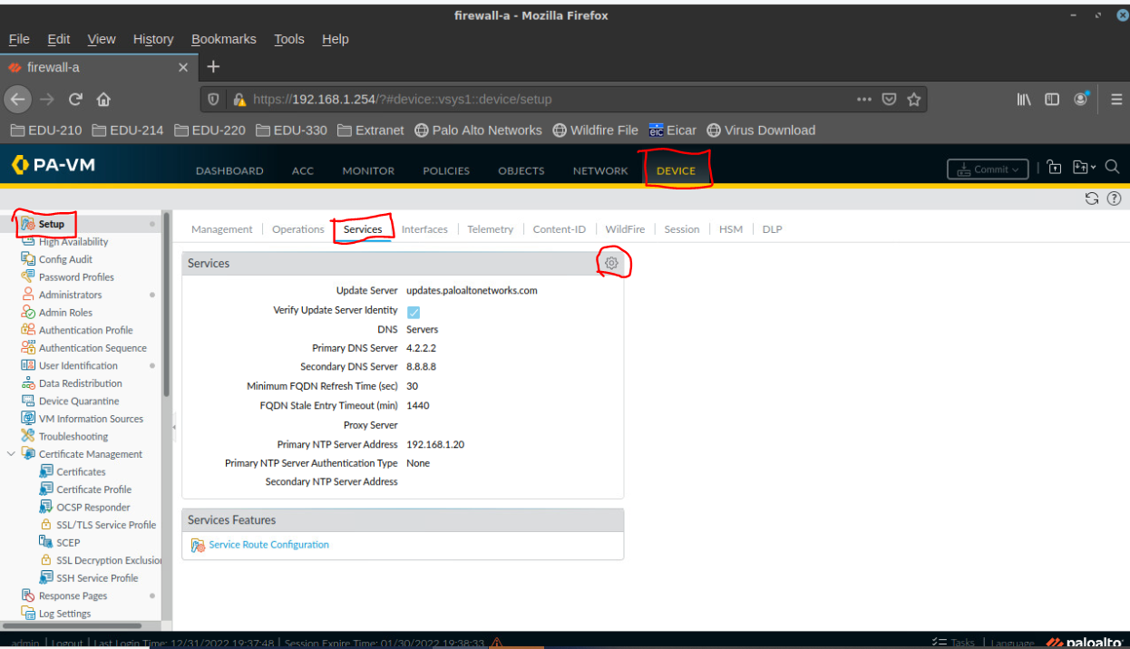

- Use the form below to change your preferred and secondary DNS servers:
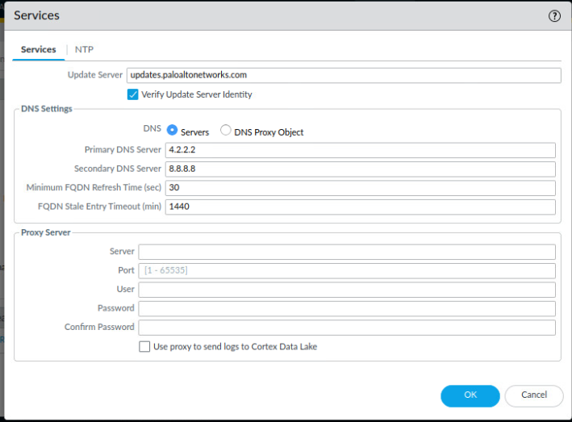
- To configure the NTP server, click on the NTP tab and change the settings using the form below:
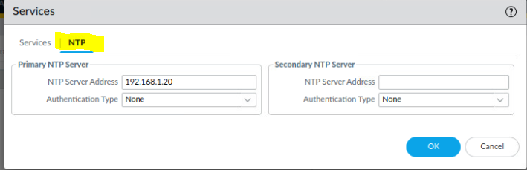

- To change general firewall settings like domain, time zone, etc., go to DeviceSetupManagement and click on the configuration icon to access the config form:

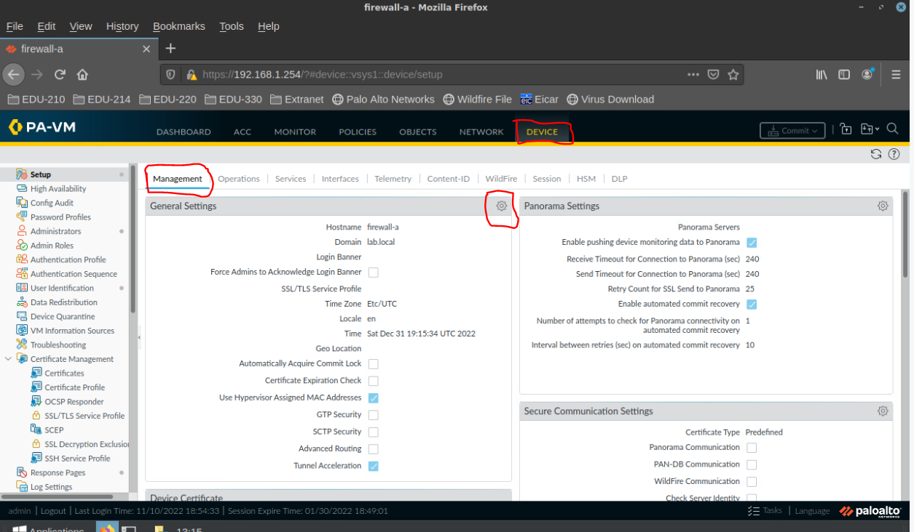

- When you are done, click commit to commit your changes and test
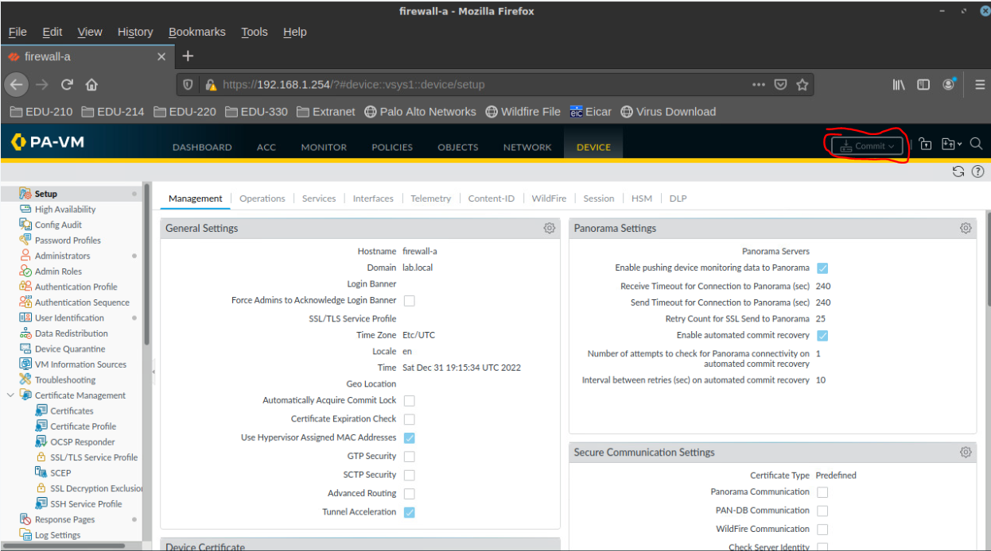

Configure Management Address and Access

- From the DeviceSetupInterfacesManagement Screen, click on Management:
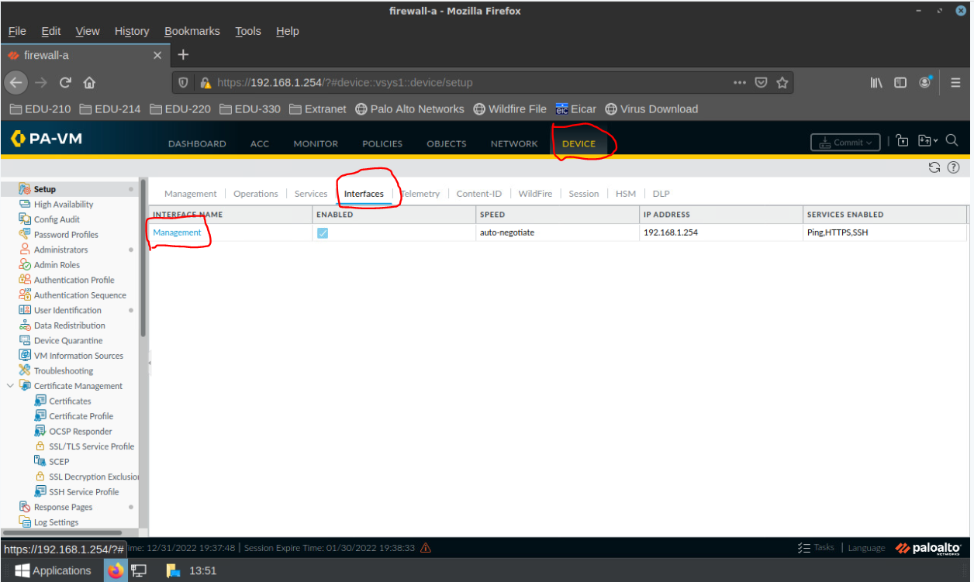

- Use the following form to set up Management Interface settings, including the address and mask, default gateway, allowed management services, network services, and permitted management workstations:

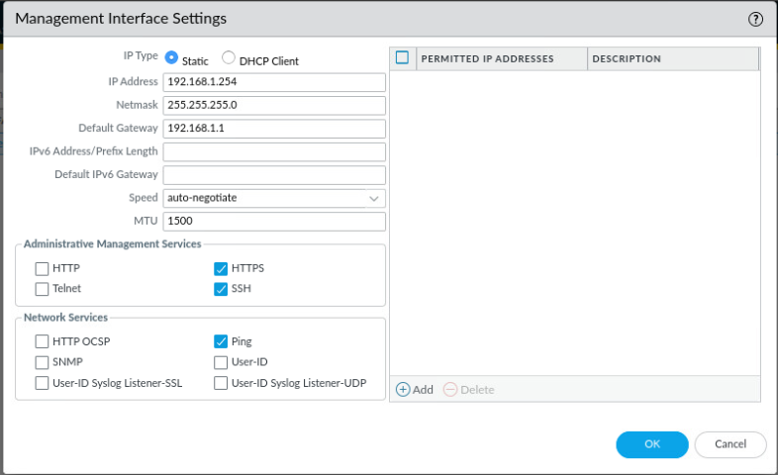
- Commit your Management Interface and check

Check for Firewall Software Updates

- To check for security and software updates, choose Check Now from DeviceSoftware

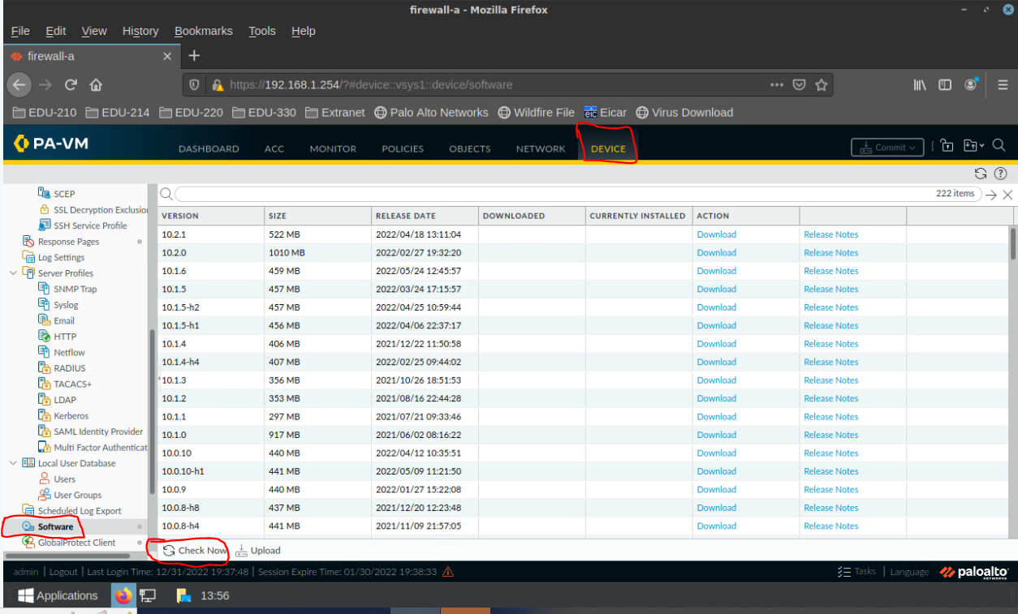

Verification/Troubleshooting:
- To verify that the DNS settings are working, you can issue a ping command, using a FQDM from the Firewall console (e.g., ping source 203.0.113.20 count 3 host www.yahoo.com) –Note that the loaded lab changes the admin password, and you will not be able to log into the firewall after you commit the load Named Config
- To verify NTP, you can check the verify the time from DeviceManagementGeneral Settings screen:

- 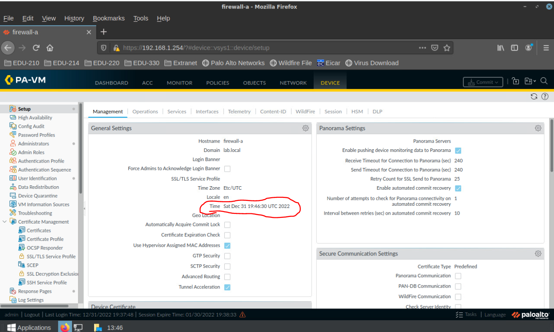

- To verify Management address, recheck the form. Also, since Ping was allowed to the Interface, ping the address from a client to ensure that it is set up. –Note Due to the admin password change in the loaded lab, you can check to see if the browser connects to the interface, but it will not allow you to log back in.

